FAX+🕿~ 03465 –255252
E-mail: hbcollege@ gmail.com.
HIRALAL BHAKAT COLLEGE

(Affiliated to the University of Burdwan in Arts & Commerce Accredited by NAAC)

P.O. – NALHATI, DIST. – BIRBHUM, W. B., Pin-731220.
Date: 17. 09. 2019
To
The Coordinator
IQAC
Hiralal Bhakat College
Nalhati, Birbhum.

Ref.: Appeal to collaborate in a One-Day College Level Seminar.

Respected Sir,
This is to inform you that a one-day college level seminar on ‘Indian Constitutional Values and Spirit in an occasion of Constitution Day Observation is going to be organized by the Department of Political Science, Hiralal Bhakat College, Nalhati,Birbhum on 26th November, 2019 at 12 Noon in Room No.18.
You are hereby requested to allow a collaboration with IQAC, Hiralal Bhakat College, Nalhati, Birbhum, in this regard for further advancement of our academic excellence as well as a sensitization about our Constitutional values and sprit among our students as helm of our country in future. In this occasion before the Seminar we would like to arrange a procession to sensitize our constitutional values and information among the nebouring society at large. we think It may be treated as an outreach programme also.

Thanking you.
Yours sincerely

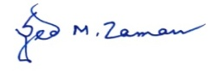
(Syed Manuaruz Zaman)
Head,
Department of Political Science
Dated, 17th September, 2019.

FAX+🕿~ 03465 –255252
E-mail: hbcollege@ gmail.com.
HIRALAL BHAKAT COLLEGE

(Affiliated to the University of Burdwan in Arts & Commerce Accredited by NAAC)

P.O. – NALHATI, DIST. – BIRBHUM, W. B., Pin-731220.
Date: 24.09.2019
To
The Head
Department of Political Science,
Hiralal Bhakat College
Nalhati, Birbhum.

Subject: Confirmation of collaboration.
Dear Sir/ Madam,
It is hereby intimidated that IQAC, Hiralal Bhakat College, Nalhati, Birbhum does hereby confirm that a collaboration in the One-Day College Level Seminar on "Environmental Priorities in India in the Context of Sustainable Development" With allies extension activities to to observe World Environment Day, dated 5th June, 2019 has been established following your letter dated 17-09-2019.
Kindly consider it as a formal declaration of collaboration in this regard and oblige.
Thanking you,
Yours Sincerely,

(Dr. Suddhasattwa Banerjee )
Coordinator, IQAC
Hiralal Bhakat College
Nalhati, Birbhum.
Dated, 24-09-2019.

HIRALAL BHAKAT COLLEGE
NALHATI, BIRBHUM
A Brief Report
on
One Day Departmental Seminar with an outreach programme (Drmocratic awareness through Constitutional & Legal literacy) as a part of Nation Constitution Day Observation in the Department of Political Science. HBC, Nalhati.
Topic of the Seminar: Indian Constitutional values and spirit.
Date: 26th November, 2019. Time:12.00 noon
Venue: Room no.-18, Hiralal Bhakat College.
Organizing Committee:
Patron: Dr. Gautam Sen, TIC & Assistant professor of English, HBC.
Syed M Zaman
Assistant professor, HBC.
Biman Saha,
Assistant professor, HBC
Nilmoni Mukherjee
SACT. HBC
Smt. Tanushree Sinha
SACT, HBC.
Fahaduddin.
GT, HBC
Convener: Syed Manuaruz Zaman
Asstt.Prof. & HOD, Department of Political Science, Hiralal Bhakat College.
Chairperson: Smt. Tanushtee Sinha , PTT of Hiralal Bhakat College,
Chief Guest / Resource Persons:
1.Dr. Suddhasattwa Banerjee, Assistant Professor in English & Co-ordinator,IQAC, Hiralal Bhakat College, Nalhati, Birbhum. W. B.
2. Sukumar Mandal. Assistant professor in History,Hiralal Bhakat College: Birbhum.W.B.

Faculty-Members of the Department :
Syed Manuaruz Zaman, Assistant .Professor. Department of Political Science , Hiralal Bhakat College.
Biman Saha, Assistant Professor, Department of Political Science, Hiralal Bhakat College.
Nilmoni Mukherjee, PTT, Department of English ,Hiralal Bhakat College.
Tanushree Sinha; PTT, Department of Political Science, Hiralal Bhakat College.
Raihana Nasrin, G. T., Department of political science, Hiralal Bhakat College.
Fahaduddin, G. T., Department of political science, Hiralal Bhakat College.

Participants:
Students of the Department of Political Science, Environmental Studies and some other departments as a whole. Almost 85 participants including some general audience were present the Seminar.
Concept Note and Objectives of the Seminar/ Outreach programme: .
National Constitution Day is also known as 'Samvidhan Divas', is celebrated in our country on 26th November every year to commemorate the adoption of the Constitution of India. On 26th November 1949, the Constituent Assembly of India adopted the Constitution of India, which came into effect from 26th January 1950.
The Ministry of Social Justice and Empowerment on 19th November 2015 notified the decision of Government of India to celebrate the 26th day of November every year as 'Constitution Day' to promote Constitution values among citizens.
In this connection we feel as an academic institution to do something for the greater public interest. Our focus group was our students as a younger generation / new voters etc.to comprehend and save or protect our Indian Constitution for the sake of greater interest, the unity and integrity of the nation.
.Details:
A one-day Departmental seminar was successfully organized by the Department of Political Science in collaboration with IQAC. ,Hiralal Bhakat College on 24/11/2019 at 12:00 noon, room no-18. The area covered in the seminar was from the various texts prescribed in the syllabus of CC-4 of Political Science Honours (CBCS) & GE-4 Semester VI, General, under the University of Burdwan. The programme was started with the auspicious event of lightening the lamp and felicitation of the Resource persons and guests. The programme was, then, inaugurated with an inaugural song sung by some of the students of Semester –VI, Dept. Of Political Science. The welcome speech was then, delivered by our one of the senior faculty members, Shree Nilmoni Mukherjre. Smt.Tanushree Sinha, one of the senior faculty member of the department chaired the whole session of the Seminar. The objectives and significance of the seminar was then, stated by the HOD of the Department Mr. Syed Manuaruz Zaman, with a full paper presentation about the very topic of the Seminar.
The next part of the programme was, then, followed by a very thought provoking lecture delivered by two honourable Resource persons one by one. It was very much enriched and enlightened our students as well as the whole audience.
The whole programme was conducted by our five faculty members including the Head of the Dept. of Political Science. The programme was concluded with a vote of thanks by Shree Biman Saha, one of the faculty member of the department..
- Outcome: The lecture of the Resource Person provides a broad spectrum on the topic and touches upon various perspective about our reach Constitutional values and Political Movements. The faculties and students came up with various questions and answers, and they were enriched with the interactions with the Resource Person. I hope it was very enlightening interesting to our students and it would be helpful to become a good and responsible citizens of our country India.
Outreach programme :
(From 10 30am.to 11-30am.
Before Seminar we arrange an extension activity or we may call it an outreach programme to celebrate this very day. We arrange a procession before Seminar at surroundings of our College Campus to sensitize our society at large about our constitutional spirit, rights, duties etc. We think without the proper understanding of our Constitution at larger level of our sociey we can't achhive the environment to protect our Constitutional spirit as unity in diversity, political, social and economic justice, fraternity etc. However, our students and general peoples were very much enthusiastic to this programme. The whole programme throughout the day was ended in a successful manner by a cooperative attitudes from all corners. Thanks to all.
Budget: Rs.3500/- (Three Thousands Five Hundred only).

Photographs:
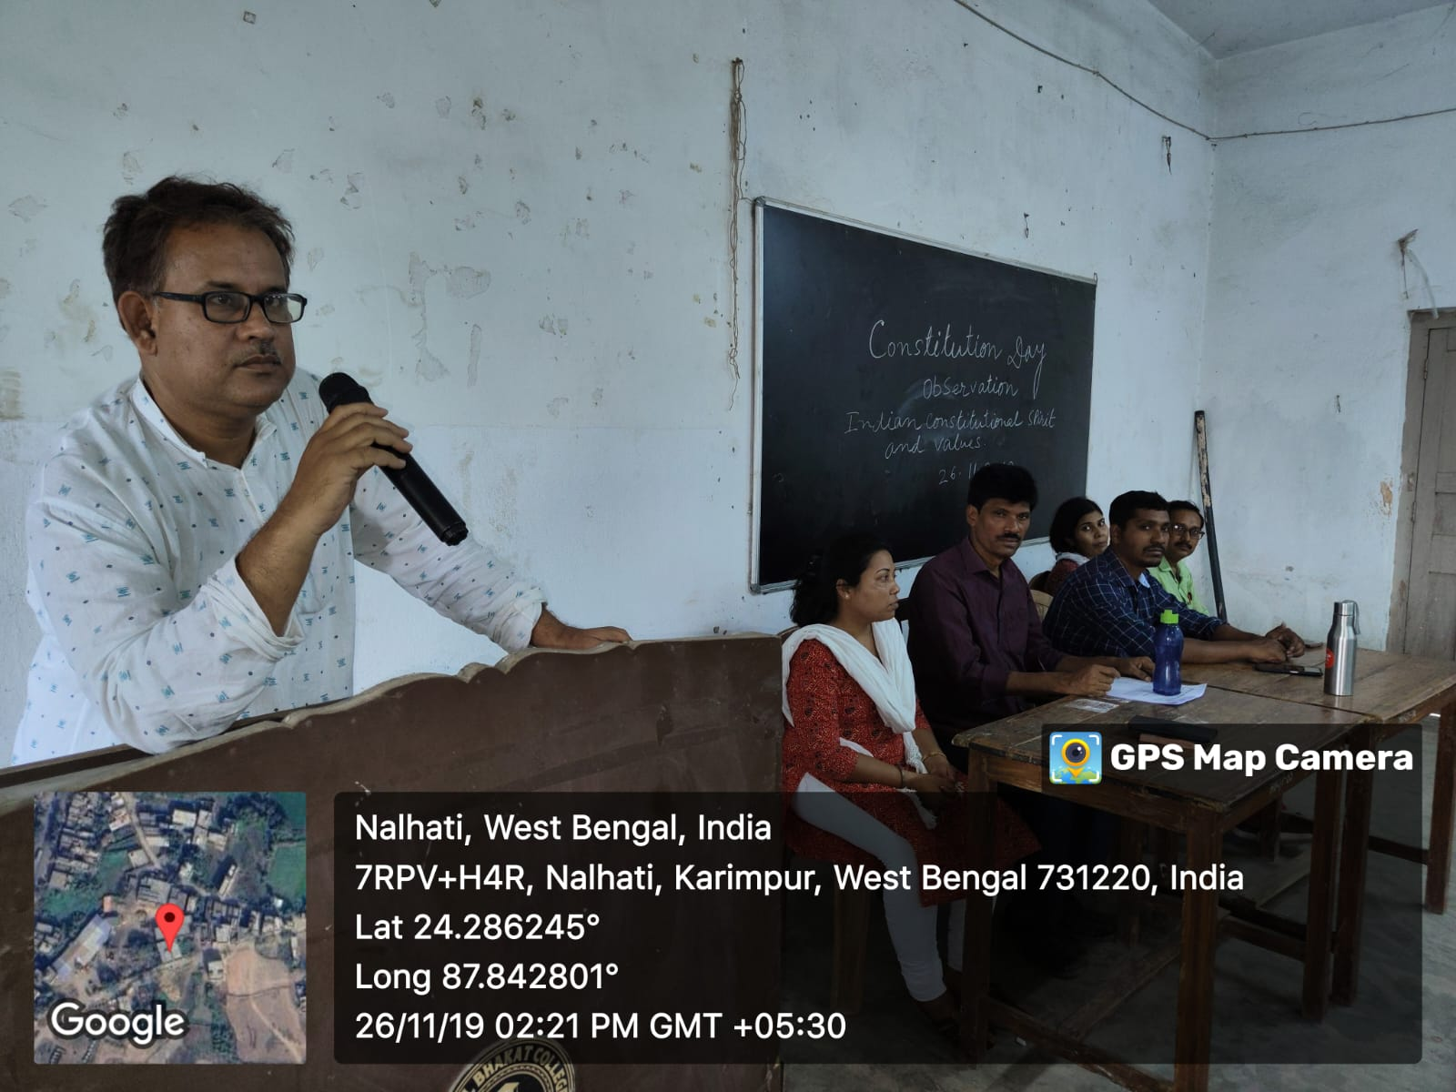

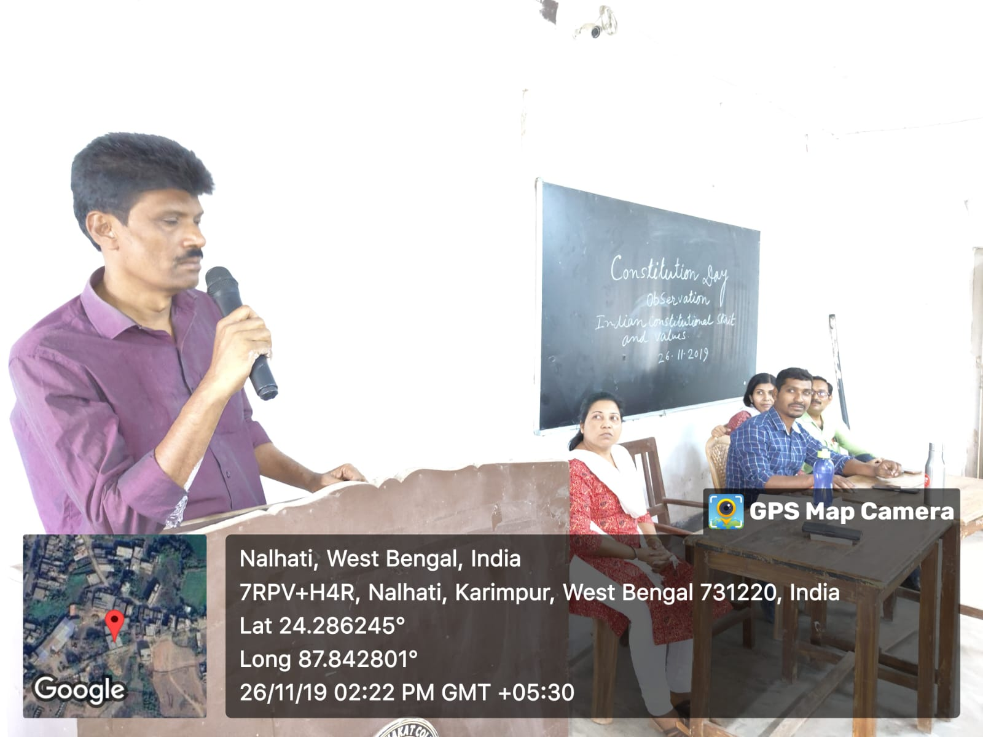

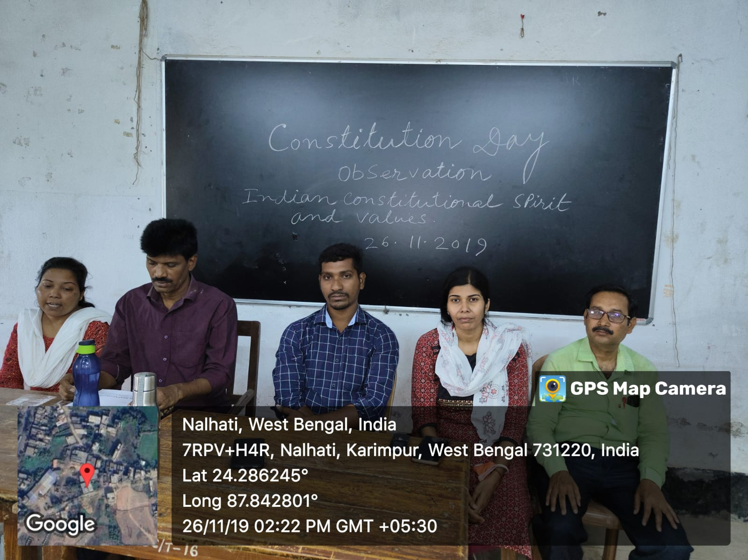

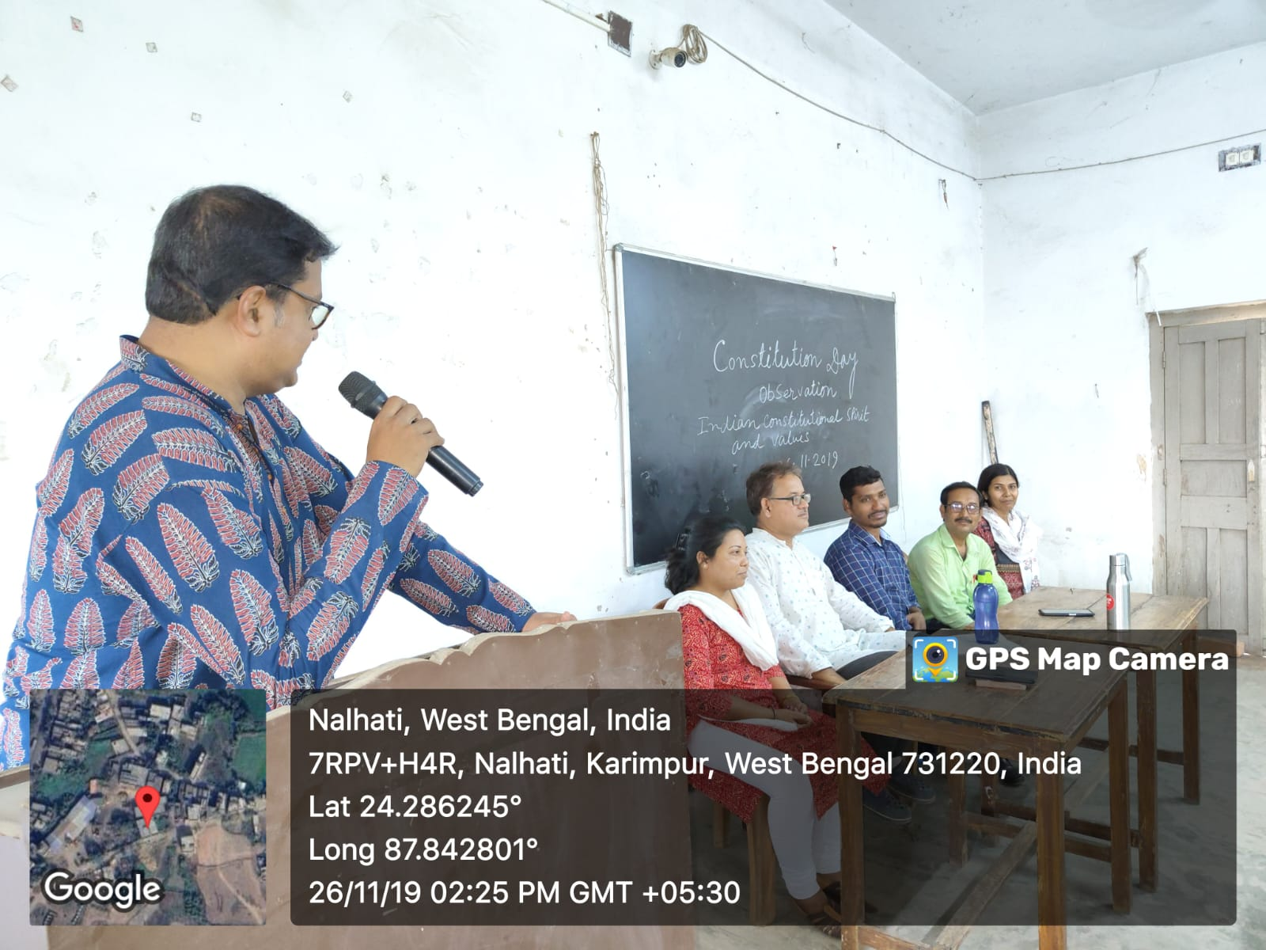

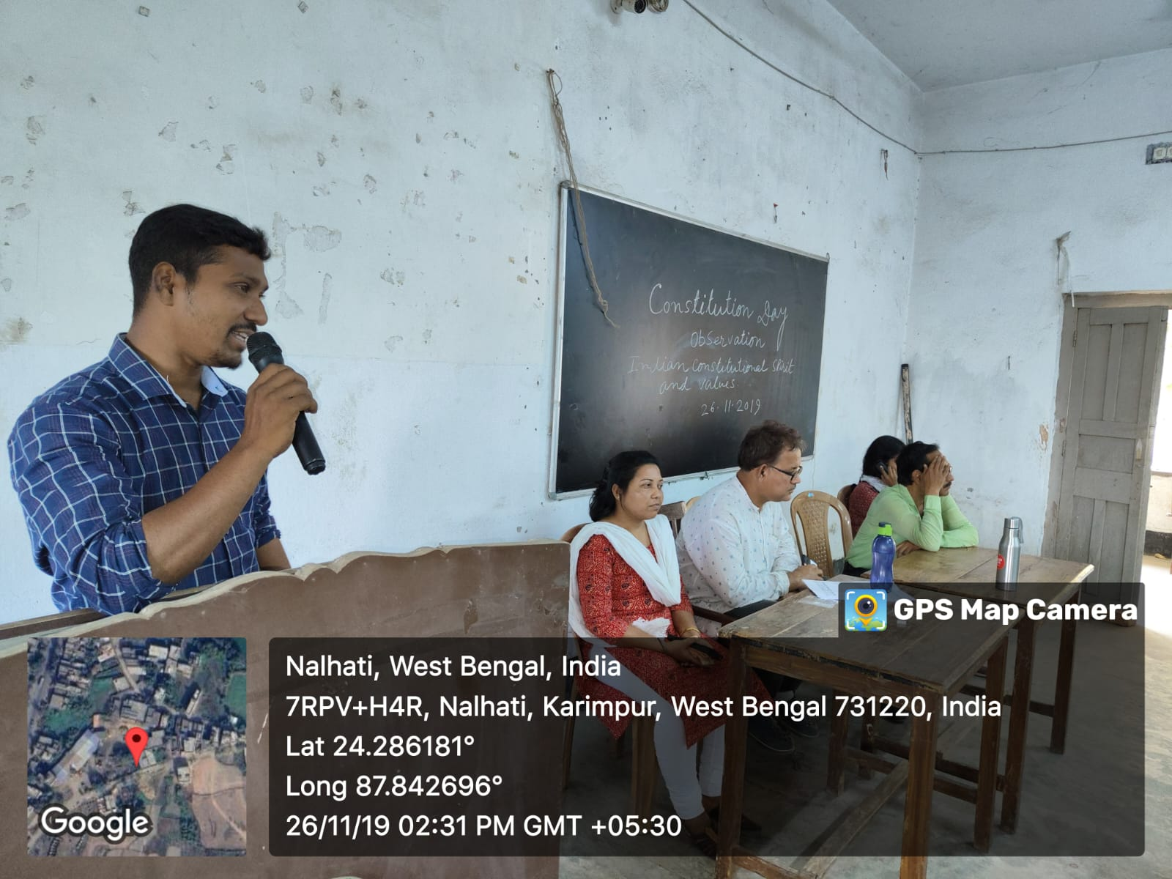

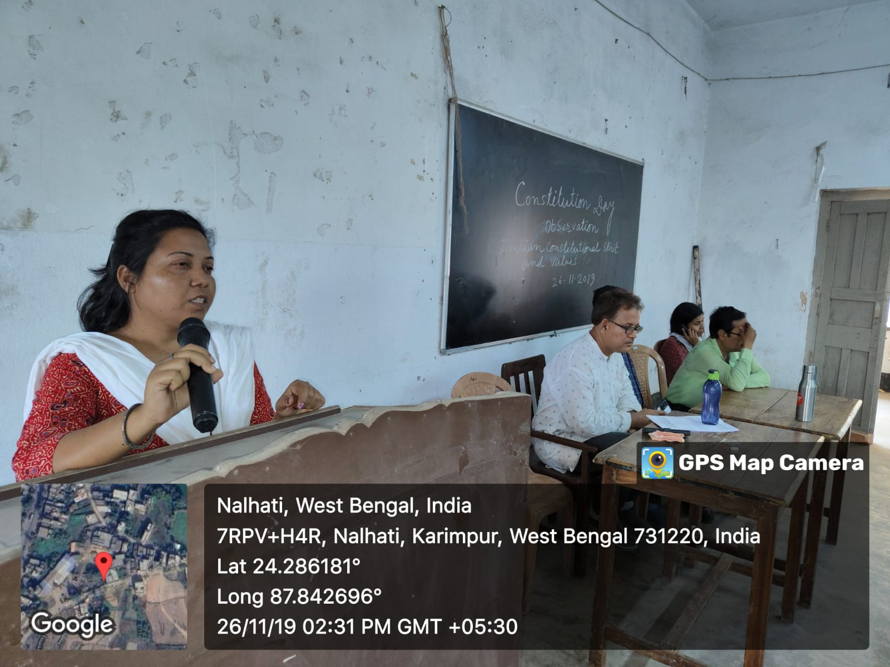

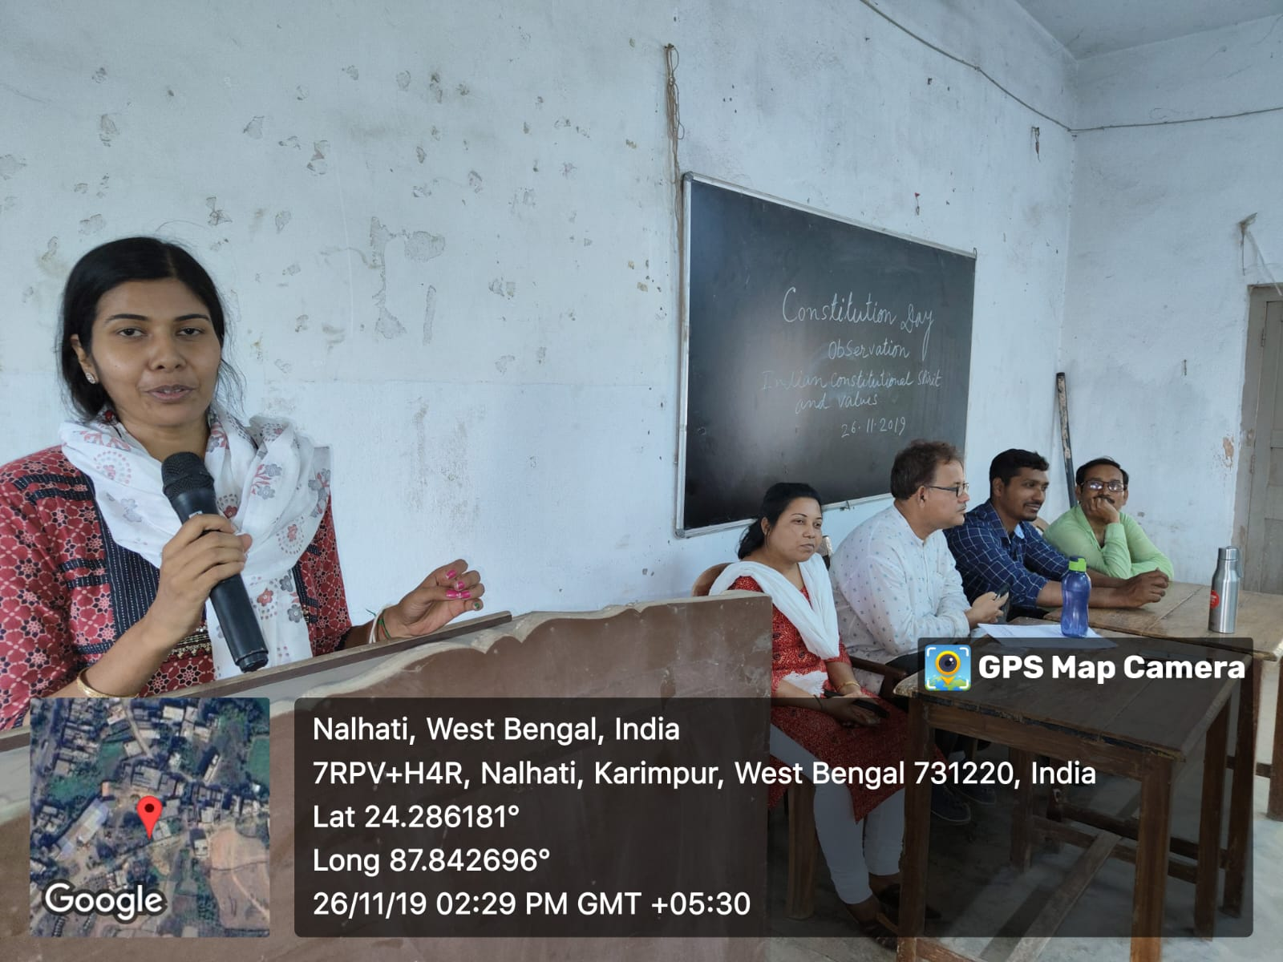
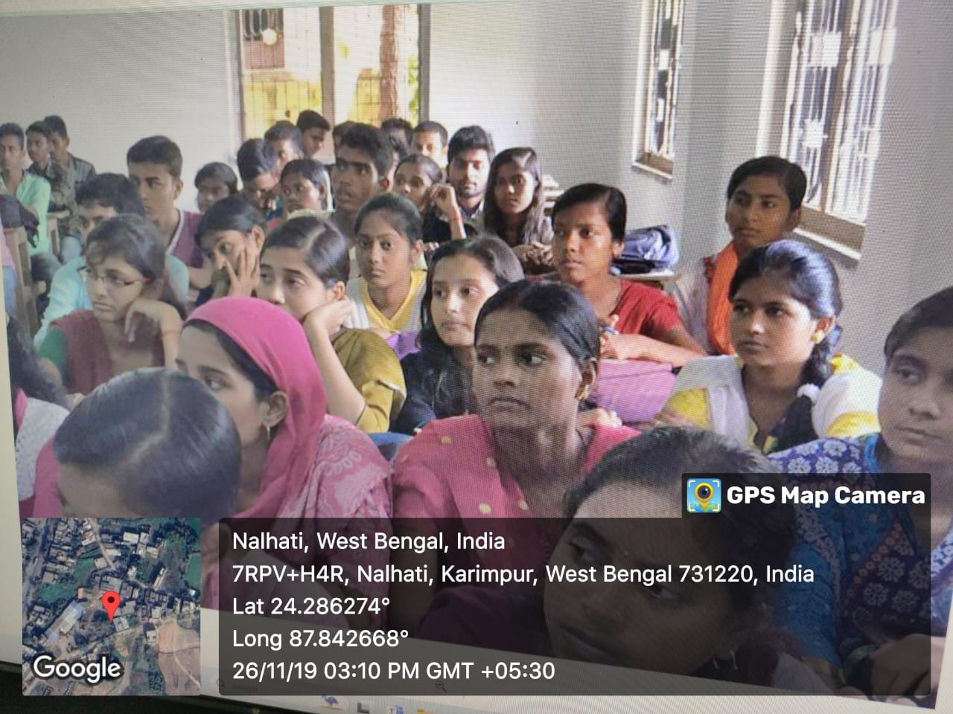

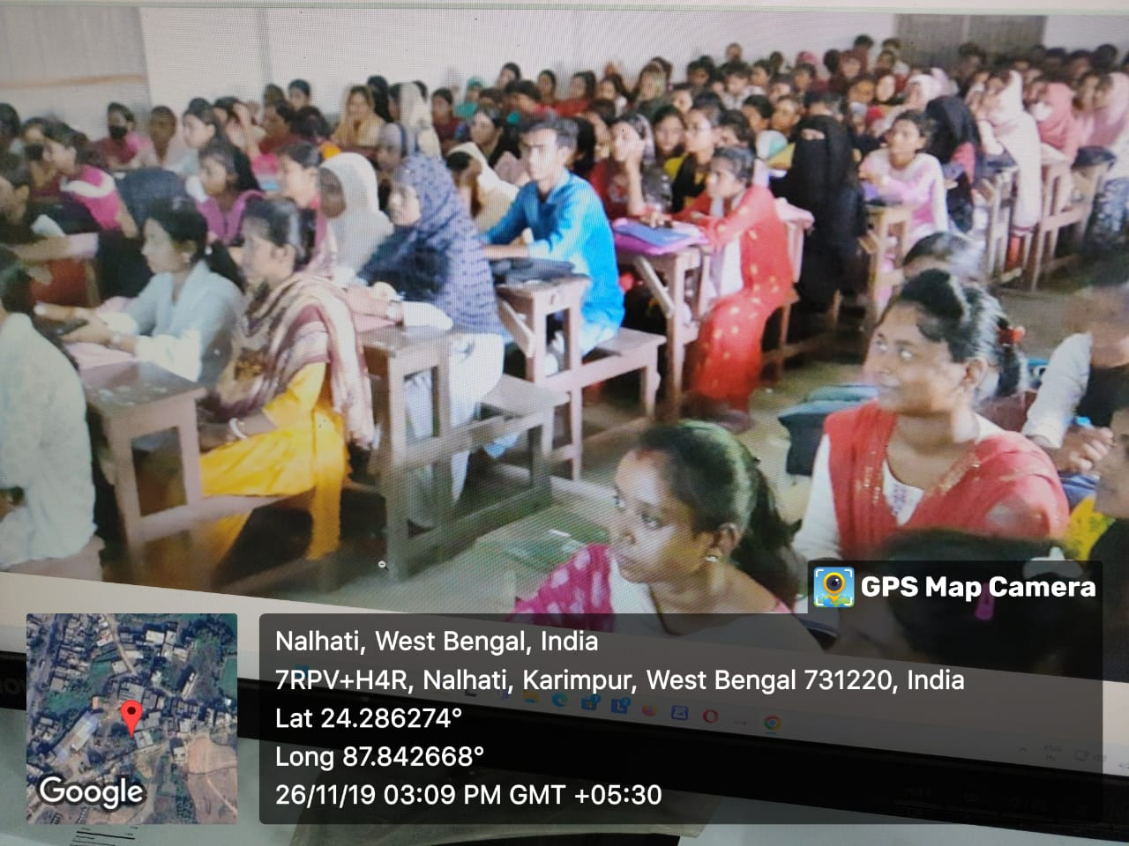

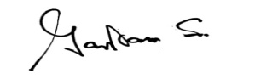
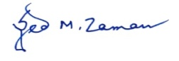
HOD Principal/ TIC
Department of Political Science Hiralal Bhakat College
HBC , Nalhati Nalhati, Birbhum.
